Name : ibraheem Qasim

Sap id : 42896

Section : BSCS 4

**Assignment 2**

**Project title:**

Music management system

**Activity diagram**

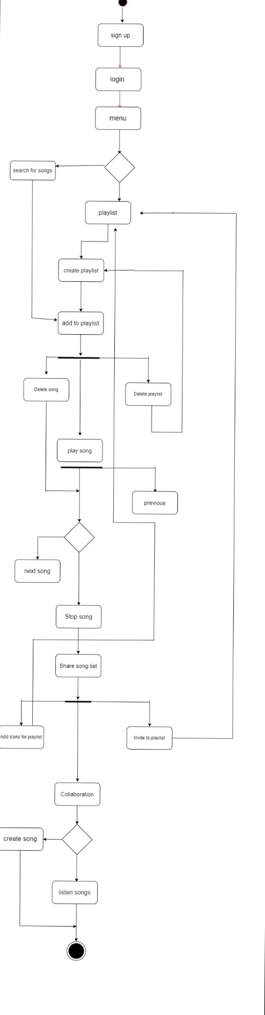

**Diagram explanation :**

The process starts with the user sign up and login in the system

after login the user is directed into the main menu where he/she can successfully create a playlist or search for the songs. After selecting the songs ,songs will be automatically listed in the playlist. The user will able to delete songs. If user want to share his playlist he can easily do it or even invite other to playlist.

Note that this activity diagram provide the overview of work flow and the actual system may have additional activites based on the specific requirement and functionality.